1. Create New Database [BikesStore] with following structure and instructions.

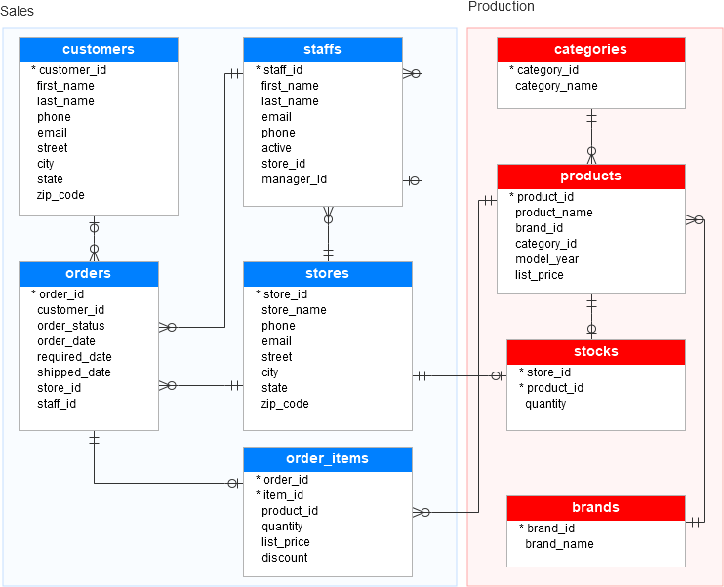

a) Assign UNIQUE KEY constraint to [email] for [customers] while creating table.

b) Assign UNIQUE KEY constraint to [phone] and [email] for [staffs] while creating table.

c) Assign CHECK constraint to [quantity] for accepting value greater than 0 while creating [order_items] table.

d) Assign CHECK constraint to [list_price] for accepting value greater than 0 while creating [order_items] table.

e) After creating table [order_items] Add new column [item_amount] by calculating it using computed column ((quantity*list_price)-discount).